LEARNING TOOLS OF PHOTOSHOP

# MAGNETIC LASSO TOOL:

# 

Original picture

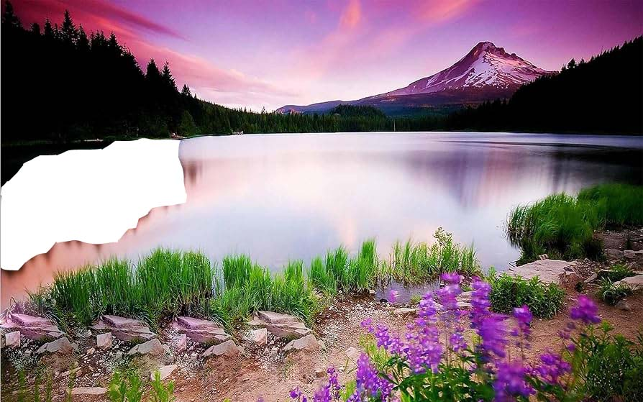

Edited picture

# PATCH TOOL



Original Picture



Edited Picture

# SMUDGE TOOL

# 

Original Picture



Edited Picture

# 4.BLUR TOOL

# 

Original Picture



Edited Picture